Final Web ui to search:

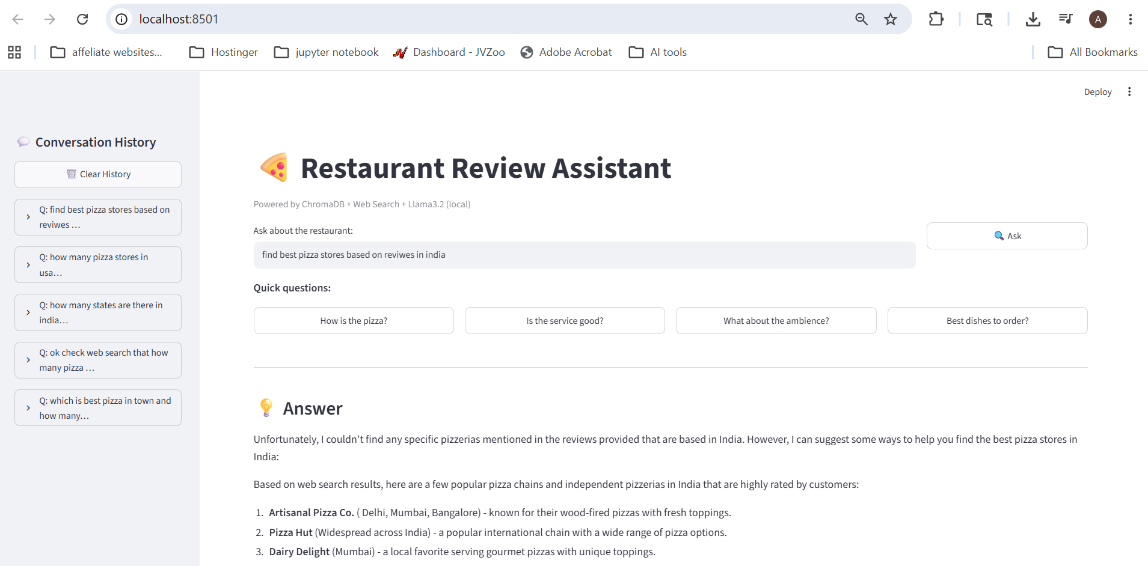

Data in persistent memory can be seen in sqllite. All previous prompts seen in sqllite
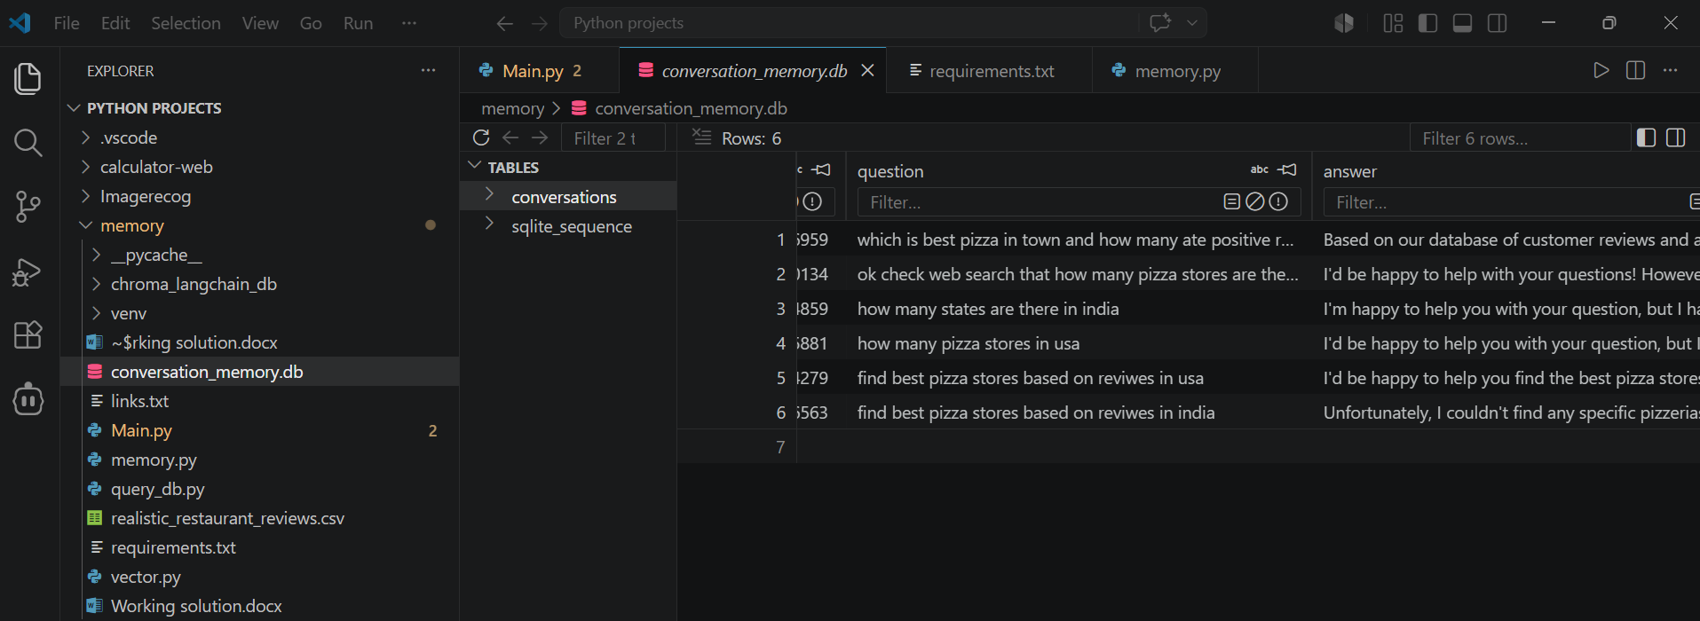

Vector in Chorma DB. Restaurant review data can be taken from chroma db
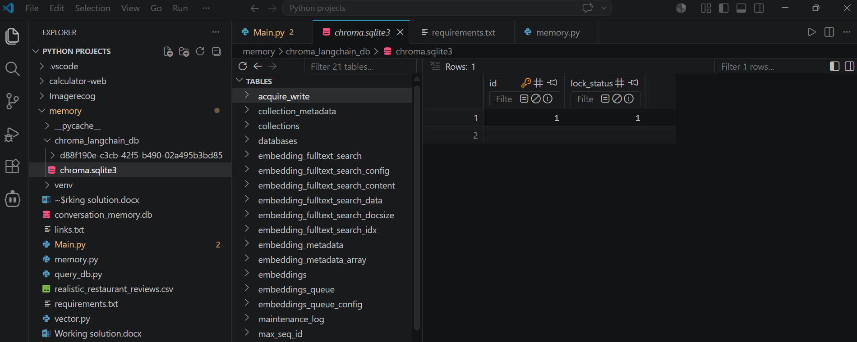

DuckDuckGo and Tavily used for web search
realistic_restaurant_reviews csv file for RAG search

